Quiz Manager Design Document

**Overview:**

Status: in progress.

This project aims is for WebbiSkools Ltd with the aim to develop solutions for education establishments and training providers.

**Content:**

Requirements:

The requirements of this project is to design, build, and test a database-driven website to manage quizzes, each consisting of a   
set of multiple-choice questions and their associated answers. The website’s capabilities will   
only be accessible to known users. Users with full permissions will be able to view and edit   
the questions and answers; users with lesser permissions will be able to view them but not   
edit them; users with minimal permissions will only be able to see the questions.

Functional Requirements:

1. The Site will rely on a database to store and manage information.
2. The Software should be a website or webapp.
3. The webapp does not need to be on the internet and can be deployed only locally.
4. The app should have some automated and manual tests making sure it’s working correctly.

Non-Functional Requirements:

1) Have 3 levels of access:

* 1. Minimal in which users will only be able to see and answer questions
  2. Lesser permissions where they will be able to view questions and answers.
  3. Full permission where they will be able to view and edit questions and answers.

1. Questions will all be multiple choice and have associated answers.
2. The Quiz questions will feature multiple choice answers.
3. The Questions of the quiz will be automatically marked, and the user will be given a score.
4. The website’s functions will only be available to known users.

User Stories:

# Create Quiz Design Sketches

Shows recently created/edited quiz which allows the user to access quickly.

Loads existing quiz

Creates new Quiz

Account info dropdown. Shows the account name and when clicked shows more options.

Signs out of account.

List of Students and which class they are in.   
  
This List can be scrolled and more students and classes can be added through the “Manage class” section.

Access Account Page

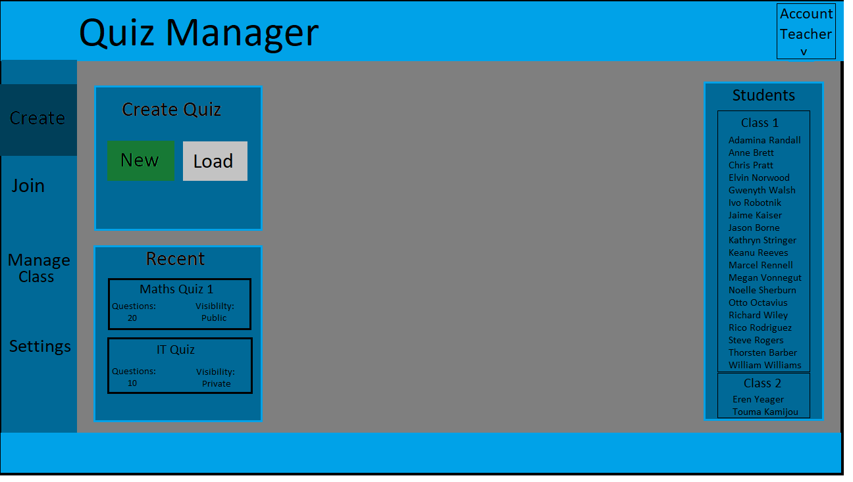

List of all the different sections that a “Teacher” account has access to.   
  
This includes “Create” which is used to create quizzes.   
  
“Join” where users can join a public quiz.

“Manage Class” Where the teacher can add or remove students and classes,

And “Settings” where the user can change different options for their account or website.

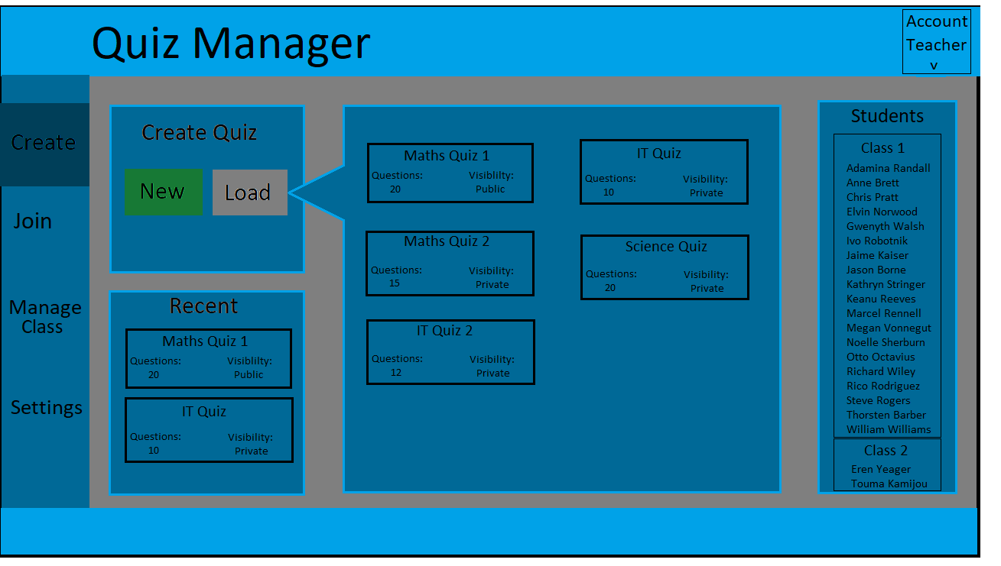

List of already made tests with the number of questions and it’s visibility (If it’s a Private quiz or Public)

Clicking on the test will allow the user to edit it.

Clicking the load button shows a menu of all the already existing quizzes.

A Scrollable list of created questions.

The darkened question is the currently selected question.

Text box for the user to enter the title of the question as well as the four different answers.

Add and remove more questions

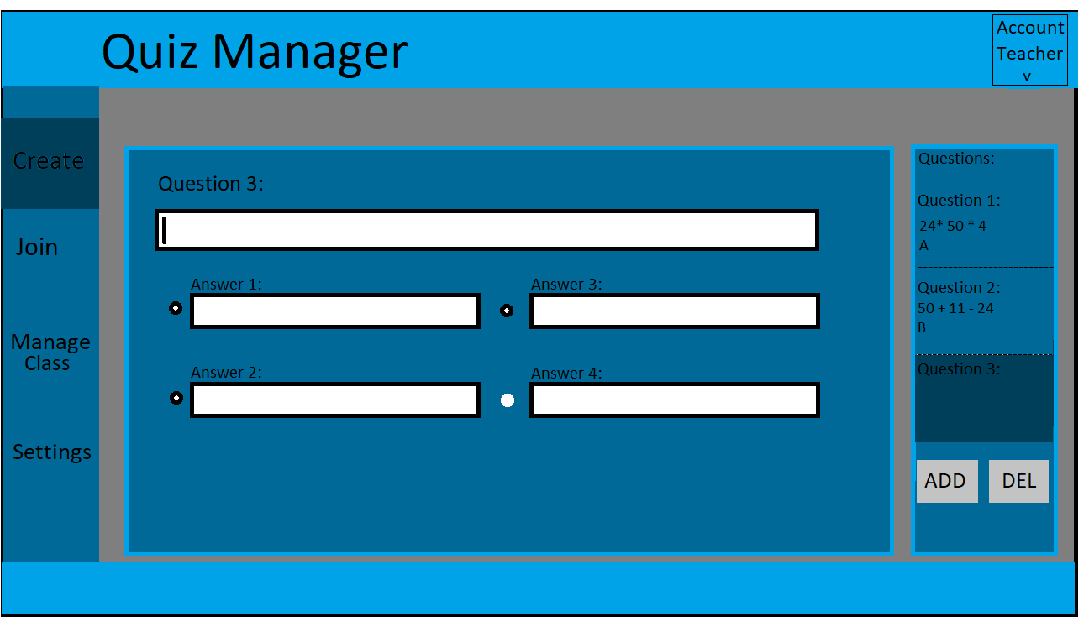

Select the bullet point on which answer is the correct one.

# Join Quiz Design Sketches

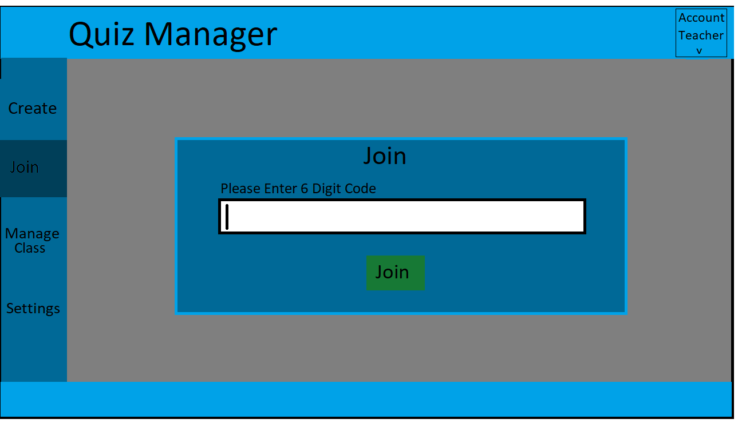

List of all the different sections.

Join button which will cause the user to join the quiz if code entered is valid.

Text box allowing the user to enter a six digit code

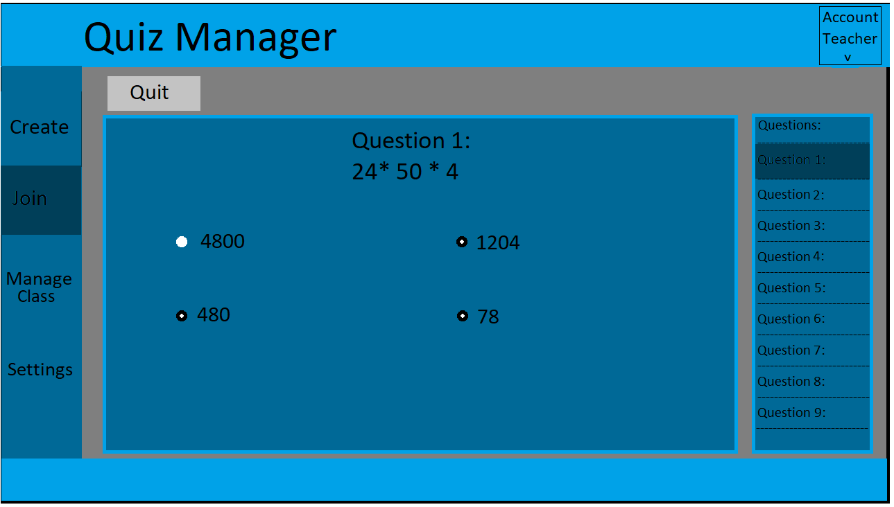

List of questions, with the dark one being the current question.

used to go back to previous or forward to new questions by clicking on the question.

Current question which will be located at the top middle.

Quit the current exam and return to the join menu.

Doing this will remove all progress.

Currently Selected Answer with the rest being unselected.

Manage Class Page:

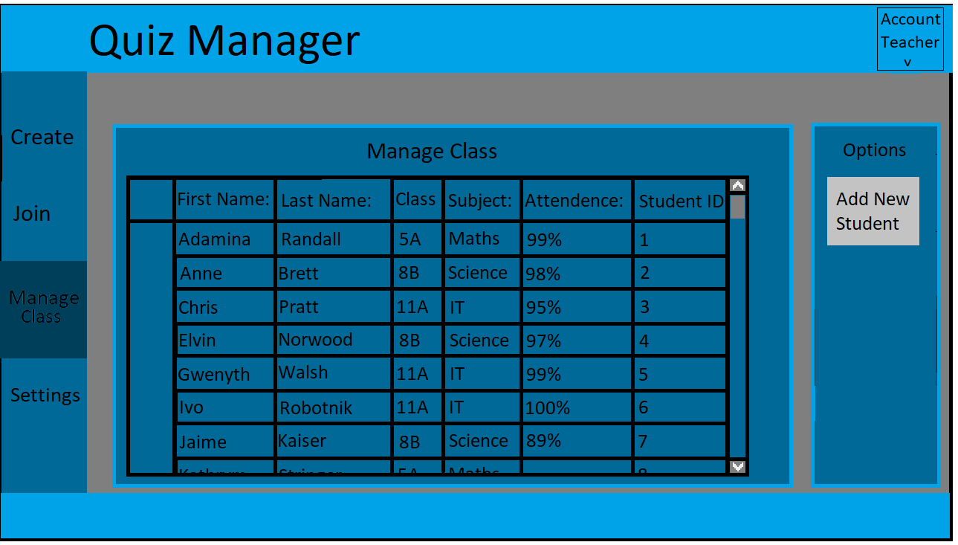

Add new student to the table (this will also bring up the Edit Screen)

The table lists all the main details of the students. Being their full name, the class they are in for that teacher, the subject they are doing, their attendance and student ID.   
  
The Student ID is an ID given to the student when the student is added to the database in order to keep better track of the student.

Clicking on any of the details will bring up a new page showing more information and allowing editing of the data.

Scroll bar to view the full list of students

Class Editing Page

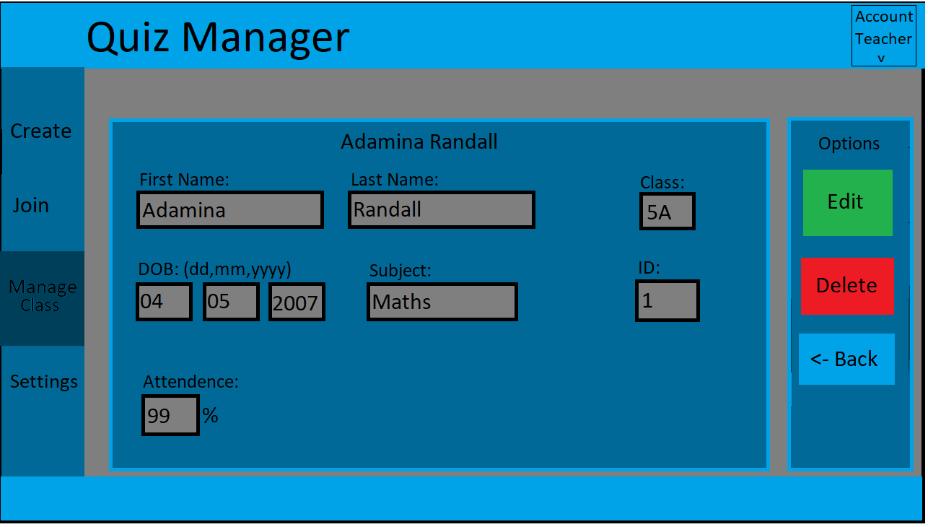

The Text boxes are greyed out and not editable till the Edit button is pressed

Deletes user account

The Edit button will cause a new page to load making the text boxes editable.

Goes back to Manage Class page

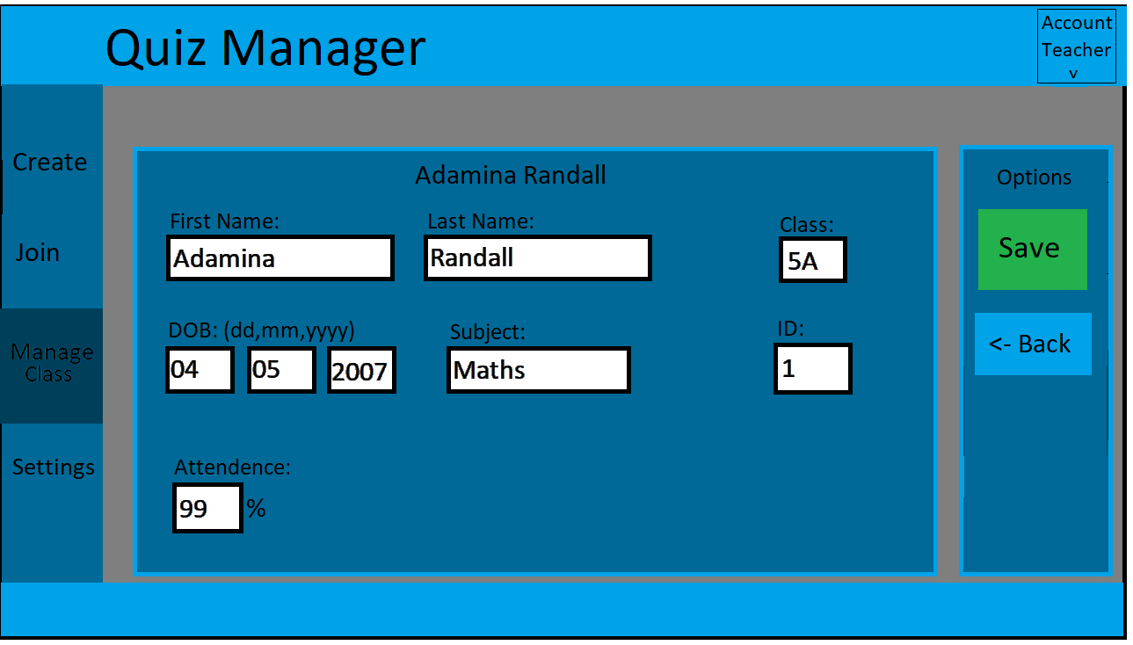

Goes back to “view page” discarding any changes

Save button will save the changes to the Database and return to the view page.

In Edit mode the text boxes and now editable.

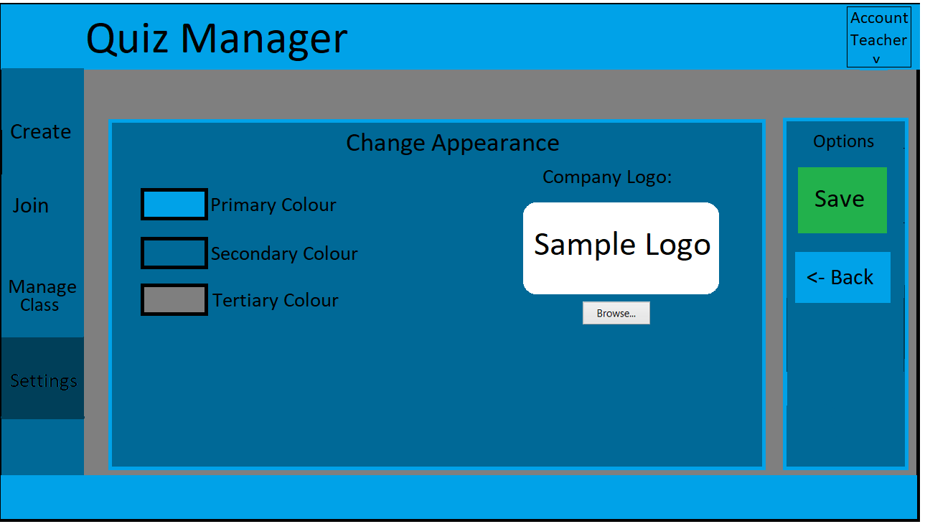

Save button will save the changes to the Database and return to the view page.